Sample
Digital Images

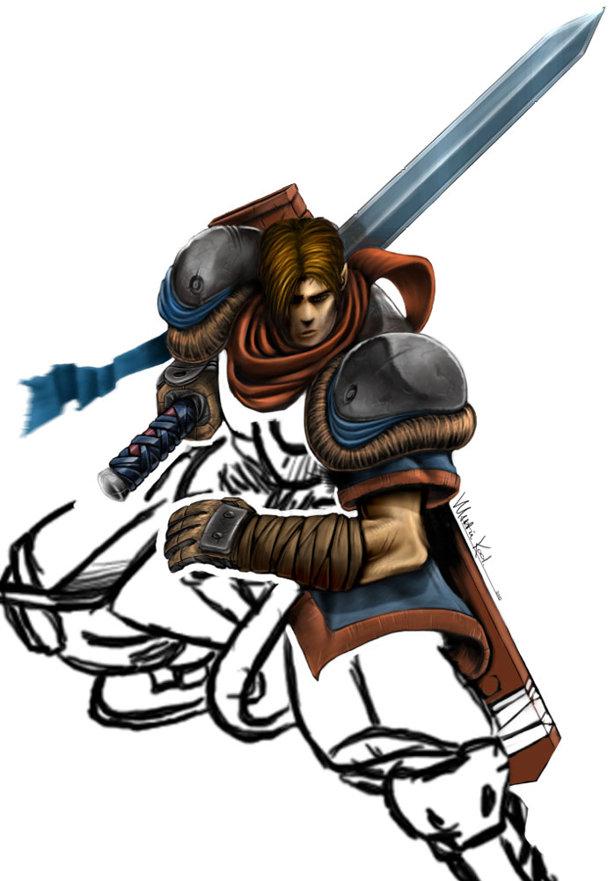 | Movies:  This is a feature artwork for an upcoming cartoon movie (yet unnamed). The half finished image gives light to how many images now a days are completed / started - here, the artist sketched a rough outline on his tablet or paper, then digitally enhance it and colour in the outline. Overall you can see how good this technique turns out – the illustration from simple black outline, to fully fledged coloured artwork is simply stunning.

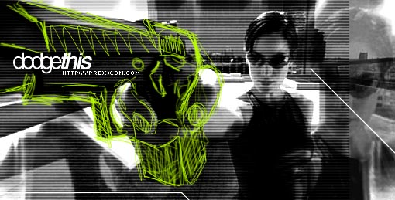 | Entertainment:  Upon the release of the Matrix onto dvd and video has started a new wave of matrix related artwork. This piece would have been a grab off dvd onto the computer, then using masking techniques and simple pencil gives this artwork a simple yet a deep design.

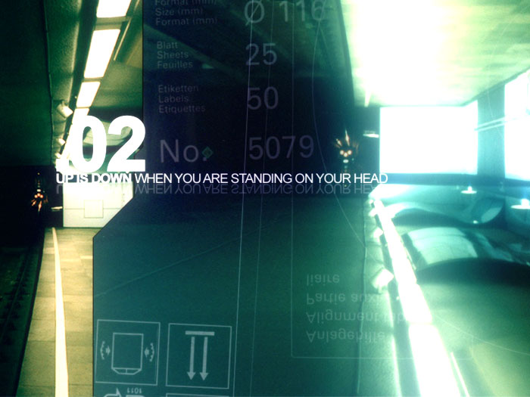 | Sport:  Combining a few digital photos, the combination of different perspectives gives this image a strange sense of a pipeline. Similar techniques have been used as the matrix one above ..

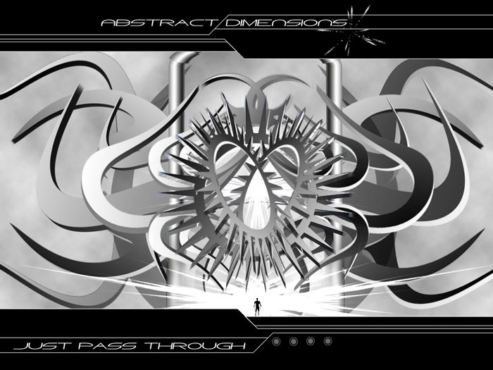 | Technology:  Unlike the other images, the basis for this image would have been constructed in a 3d rendering program, ie. 3dsmax or rhino3d, then edited in an illustration program such as photoshop or psp. As the header implies, this is more an abstract image – one that appeals to me … and with the use of the metallic rendering and colours, I thought this gave me a technology sort of feel.

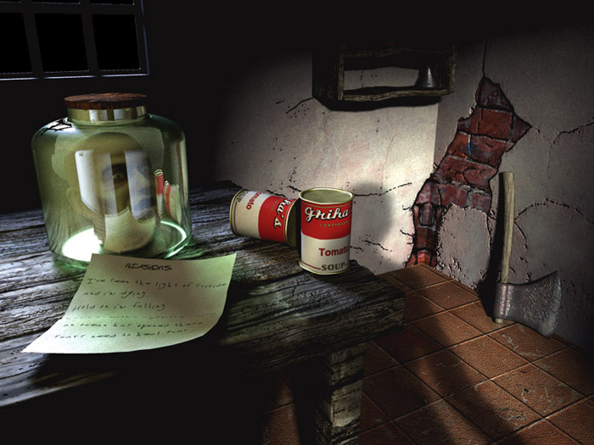 | Other:  A completely digitally designed artwork. Personally, this would of taken an extremely long time to construct and design. Features such as the glass rendering and the realtime shadowing and shading could have been done in programs such as 3dsmax. The general design most probably would have been done in general illustration utilities such as photoshop, psp etc.

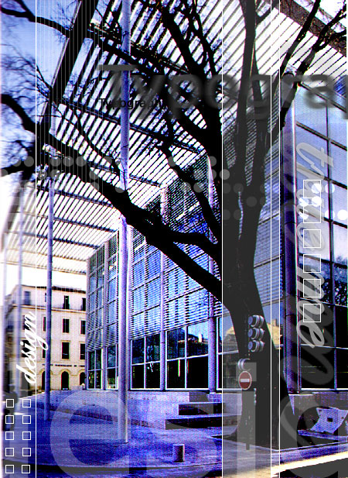 | Education  Digital image of a elementary school in Pittsburgh. Simple editing of the image with touchups masking and blue colour blend over the image gives a general soft feeling over the whole image.

